Working title: Trophic phenological mismatch: Disconnects between underlying ecological theory and climate change responses

***Introduction***

Climate change is causing phenological shifts (i.e. timing of life history events) at highly variable rates across species in different functional groups and trophic levels. Such species-specific variation in response to climate change is leading to changes in the relative timing of key activities (phenological synchrony) among interacting species (REF; Kharouba et al.). These changes in synchrony have led to fitness consequences for the consumer and have influenced ecosystem-level properties in some contexts (REF) but not others (REFS). While there have been theoretical and empirical studies done in single systems, we still have no ability to predict the outcomes and the consequences of shifts in synchrony. Regardless of the study aim in trophic synchrony literature, if the goal is prediction, then the testing of appropriate theory is necessary.

Here, we argue that part of the difficulty in predicting the consequences of climate change-driven shifts in synchrony is that there is a disconnect between ecological (and evolutionary?) theory and the current approach in the trophic synchrony literature. We focus on the widely-cited Cushing match-mismatch hypothesis (1974- this seems to be the first complete proposal of the hypothesis, 1967 and 1969 seem to each only have parts), the most commonly applied hypothesis to consumer-resource interactions in this literature. We expand (?) the hypothesis to a dynamic, non-stationary world, a link that has not yet been put forward and propose an integrative framework ?? that…does something… Previous expansions of the concept have included food abundance, spatial mismatch and ecosystem level (Durant et al. 2007)]. *However, these expansions have not incorporated pre-climate change baselines and assumptions of stationarity.* Such theoretical development and subsequent empirical testing will be necessary to move from documenting impacts of climate change to predicting the consequences of climate change on communities. Our aim is NOT to put forward additional hypotheses about when and by what magnitude changes in the relative timing of an interaction may lead to consumer consequences, but rather to ____.

[Need to find a spot: climate change offers a pseudo-experiment for the Cushing hypothesis]

In this review we review the current approach in the trophic synchrony literature, the main theory…

***Current approach***

To elucidate the mismatch between the underlying theory and our current understanding of trophic synchrony changes in response to climate change, we start by reviewing the current approach. To date, there has been work on i) documenting how climate change is affecting the timing of a trophic interaction; ii) how those changes in synchrony have affected the consumer’s (and less frequently the resource) fitness *~~(hereafter called ‘applied studies’)~~*; and iii) advancing the theory necessary to predict long-term demographic changes due to changes in synchrony ~~(hereafter called ‘theory studies’)~~. The ultimate goal of ~~both of~~ these studies is to predict the impacts of climate change on ecological communities *(hereafter called ‘climate change’ studies)*. There are also studies that aim to understand the underlying processes related to timing (e.g, coevolution, life history trade offs, food web dynamics) that drive consumer or resource dynamics (hereafter called ‘fundamental studies’— included here should be the true tests of Cushing), independently of climate change. Combined, these studies have improved our understanding of the importance of the relative timing of an interaction for consumer fitness.

***Overview of main ecological theory***

The ecological theory common to most of these studies is the Cushing match-mismatch hypothesis (1974; Figure 1). [ADD some numbers here- how many times cited?] It emerged from the marine fisheries literature as a way to explain the variation in population recruitment of fish stocks but has had broader implications for the ecological literature since then, especially given recent climatic changes. Based on life-history theory, it postulates that there should be selective pressure for the consumer to ‘match’ the timing of the peak of its most energetic phase with that of the timing of its peak resource availability (Figure 1). Given this strong selective pressure, if there is any change to the relative timing of that interaction, there will be a decrease in fitness for the consumer (Figure 1). For example, if the consumer emerges too early in the spring, the resource will not be present and the consumer will risk starvation. At the limits, consumer fitness should fall to zero when there is a large enough change to relative timing. In the sample example, the consumer can only survive so many days without food. Two important requirements must be met in order to apply the Cushing hypothesis. First, consumer and resource must present a certain degree of seasonality (Durant et al. 2007). Second, the resource is the major control on consumer (i.e. strong interaction strength).

For ‘climate change’ studies, the Cushing hypothesis offers a testable, generally applicable hypothesis for predicting *long-term demographic changes* in response to climate-change driven shifts in synchrony. It has the potential to improve our predictions about these changes by predicting the magnitude and direction of fitness change (Figure 2).

*For ‘fundamental studies’, understanding the baseline state of the system is needed to know whether the system is at equilibrium or only transient (e.g., life-history trade-offs end up in some sort of equilibrium but if climate change has pushed your system off baseline then you may be looking at transient dynamics when you should be looking at equilibrium; similar for co-evolution, it predicts and arms-race but that arms-race varies a lot under stationary climate versus non stationary climate)* (Fig 2).

***Disconnect between theory and empirical studies***

[LIZZIE] Many research areas in the biological impacts of climate change literature focus on direct relationships between organisms and the environment, with much progress coming from cross-disciplinary work including perspectives from physiology and biometeorology (Cleland et al. 2007 (TREE) and something by Korner?). Progress on the Cushing hypothesis, however, requires combining an understanding of how organisms directly respond to the environment with tests of a diversity of ecological and evolutionary theory. This represents the major challenge of the hypothesis and, possibly, why support for it has been so mixed.

In its original state, the hypothesis had been debated, contested and criticized, particularly in the marine literature (Durant et al. 2007, Leggett and DeBlois 1994;*). In part because, although a relatively simple hypothesis, it is inherently difficult to test, an assertion even Cushing himself made. When explicitly tested, there has been unequivocal support for it (ref). However, when not explicitly tested, the shape and strength of the relationship between consumer fitness and the relative timing of the interaction varies greatly (ref). Others have suggested that this is because of data limitations and the model’s implication of complex multitrophic dynamics (Kerby chapter, Durant et al. 2007). We argue that there are additional key methodological and conceptual reasons that make it difficult to synthesize individual tests of the hypothesis to determine whether this hypothesis is widely supported in the context of climate change.

First, most studies do not actually provide strong tests of the hypothesis to begin with, making it difficult to refute the hypothesis if no evidence is found. Ideal tests of the Cushing hypothesis should (1) incorporate the entire potential range of relative timing so that the limits of the system are included (i.e. X axis); and (2) establish a clear peak in fitness across the range of relative timing. It can be challenging for a short-term observational study to capture the full range of the fitness or relative timing axis within the timespan of the study. *Speak to average length of study.* However, without the complete range of conditions, it is difficult to know the shape of the true relationship. At the limits at both ends of the relative timing axis, fitness should be zero; beyond a threshold number of days without food (i.e. a complete mismatch), there can be zero growth or development. *Needs to be further flushed out…*

Second, establishing a baseline in the system has important implications for the Cushing hypothesis in climate change and fundamental studies; yet, the concept of pre-climate change baselines is rarely, if ever, considered by trophic synchrony studies. Most ecological time-series in trophic synchrony studies began in the early 1980s, at the same time as recent climate change. In these cases, it is not known what the pre-climate change baseline *should* be (Figure 2). Most studies with longer time-series that extend into earlier decades than the 1980s do not define a pre-climate change baseline and therefore implicitly assume conditions of stationarity. This is problematic when climate change has led to non-stationarity to different extents in different systems (Wolkovich et al. 2014). Further, many applied studies confound a pre-climate change baseline with the peak of Cushing curve (i.e. the baseline expectation is that fitness was highest before climate change)(Figure 2). The resulting prediction is that climate change will decrease consumer fitness by changing the relative timing of the interaction. However, without knowledge of the pre-climate change baseline, it is difficult to predict the direction and magnitude of fitness consequences due to shifts in synchrony.

An alternative hypothesis recently put forward by Singer and Parmesan (2010) suggests that asynchrony may actually be the baseline in some contexts making it even more challenging to anticipate the effects of climate change. ...more about this…). Figure 2

For fundamental studies that want to understand the underlying processes of consumer-resource dynamics, recognizing that these dynamics are occurring in the context of climate change, our current reality, is key. To this end, an understanding of the system’s baseline state is important for providing context and designing studies. *Currently, many fundamental studies are not explicit about their baselines.* The baseline before recent climate change began (early 1980’s) will determine whether the current system should be in equilibrium or transient dynamics. For example, if climate change has pushed the system off of baseline, then the system might be under transient rather than equilibrium dynamics

Third, it is unclear in which contexts (or systems) we should even expect to find support for the Cushing hypothesis. In some systems it is unclear whether an increase in the number of days between consumer and resource life history events is actually worse; again making it difficult to know the shape of the true relationship. A key assumption of the Cushing hypothesis is that the resource is a major control of consumer dynamics. Yet, the relative contributions of bottom-up vs. top-down effects on consumer dynamics remains poorly understood (e.g. Boggs and Inouye). Therefore, in many systems, we are lacking an understanding of the basic biological details needed to test this relationship.

[LIZZIE] Fourth, **many mechanisms could produce the Cushing curve**, and they most likely vary across systems, space and time. For example, mechanisms arising from **life-history theory** could produce the Cushing curve—as consumers maximize their fitness through ideal timing with their primary resource—and this forms the theoretical basis for the original hypothesis. The Cushing curve, however, is also connected to **food web theory**, since it is about timing of a consumer to its food resource, but studies deviate in what forces they hypothesize to control the peak in the food resource (a critical component of the Cushing curve, see our FIGX). For example, in aquatic systems—where top-down forces are generally more common compared to terrestrial systems—many studies suggest that the resource peak is controlled by release from, or predation by, a consumer (CITES?). This is a very different hypothesis from others that suggest seasonality in the environment will produces the resource peak (CITES).

[LIZZIE] The diversity of ecological theory that could produce the basic shape of the Cushing curve makes match-mismatch an exciting research area, it also means different researchers may collect very different data, depending on what mechanism they suspect underlies the curve in their particular system. Researchers studying the curve from the lens of life history theory require per capita estimates of fitness, including mechanisms of fecundity and mortality and how they vary across life-stages. Ideally these metrics would be assessed for both the resource and consumer, but such data are extremely rare in match-mismatch studies. Many studies instead do not collect per capita data, making it difficult to assess fitness consequences at the level of selection (i.e., the individual), thus making it impossible to directly link any fitness changes to timing. Many other studies have per capita data, but only for the consumer, making predictions of the full interaction difficult since the mechanistic understanding ends at the consumer level.

[LIZZIE] Studies addressing the Cushing curve from the perspective of food web theory often collect more equivalent data on the resource and consumer, but may not assess fitness consequences. Part of this difference may stem from differing generation times—studies that can easily observe a resource curve shaped by predation often focus on organisms with generation times on the scale of days to week. For example, aquatic studies that focus on phytoplankton as the resource may observe many generations in one summer while a terrestrial study focused on caterpillars would generally observe a comparably smaller number generations (X-XX, depending on latitude and species for caterpillars). Such deviations across systems, however, may fall away at the level of vertebrate consumers (e.g., fish and birds), but a fundamental difference in the scale of generation times pervades aquatic/terrestrial comparisons (Gruner et al. 2008, A cross-system synthesis of consumer and nutrient resource control on producer biomass; Borer et al. 2005, What determines the strength of a trophic cascade? ) and may underlie a focus more on mechanisms related to food web theory in some studies (CITES). A further divide across studies may come from the size of the consumer: when consumers are too small or turn over too quickly to track, researchers struggle to collect robust data on individual fitness.

[LIZZIE] This places Cushing curve studies on a continuum: at one end, some studies, focused generally on food web mechanisms, collect equivalent data on the consumer and resource but no fitness data and other studies, focused on life history theory from the lens of the consumer, collect individual-level data on the timing and fitness of the consumer, with much less information on the resource. The fundamental problem with these approaches is that researchers test only one piece of the much larger field of mechanisms that could underlie the Cushing curve. If they find their mechanisms explain little of the variation they observe, they often do not have the data to test alternative hypotheses. This is a rising issue in the field (and one that permeates ecology), and researchers have pointed out how a larger perspective on life history, such as including other sources of mortality beyond those related to resource access, can lead to alternative predictions than the synchrony predicted by the Cushing curve (CITES, Singer & Parmesan, Johannsson & Jonzen).

[LIZZIE] The fundamental outcome of the various mechanisms that can produce the Cushing curve is a current field where it is difficult to partition variation in the collected data to multiple hypotheses, because critical data on the resource or consumer are not collected. Though it is highly possible that both food web and life history theory together explain many of the consumer-resource systems studied, data limitations make it hard to assess both hypotheses at once. Unless researchers are extremely clear about the mechanistic hypotheses they are testing, progress could be slow.

***A path forward (new integrative framework??)***

In order to move the field of trophic synchrony forward with the ultimate aim of predicting the consequences of shifts in synchrony due to climate change, we discuss and prioritize steps future studies can take. We group our suggestions into three classes in decreasing priority: gold, silver and bronze standards.

1. Gold standard: *Integrate long-term observational studies with experiments*.
2. Long-term observational study (i.e. that starts before early 1980s) that (1) shows clear evidence of baseline conditions (aka stationarity); and (2) has independent phenological measurements for both resource and consumer. Ideally, phenology would not be measured based on population-level metrics. For example, the peak date of activity is based on 50th percentile abundance. Here, the relationship between phenology and fitness is difficult to separate. In aquatic systems, the phenological measurements of the resource would not be impacted by the consumer at the time of measurement.
3. Use experiment or some other method (process model) to understand phenological cues (need more details) and limits to fitness both in terms of peak and zero. Experiments are needed to manipulate the timing of the interaction. Gold standard experiments are those conducted against a meaningful baseline and push the system to the limits at both extremes.
4. Silver standard: *Comprehensive observational studies or experiments.*

In some systems, it may not be possible to integrate long-term observational studies and/or to do experiments. In these cases (and in the gold standard studies), scientists should strive to have:

1. Higher resolution phenological data. In aquatic systems, there is quick turnaround between producers and consumers- temporal sequencing is difficult to determine therefore sampling frequency is important; AND- some zooplankton not in complete dormancy, some remain at low densities.
2. Full extent of resource variation (e.g. Deacy et al. 2017). Clarity on diet breadth would help calculate interaction strength and thus determine whether one of the main assumptions of the Cushing hypothesis is supported. Interaction strength could influence the degree to which the relative timing of an interaction responds to climate change and the magnitude of those consequences for consumer fitness. In a recent meta-analysis (Kharouba et al.) evaluating the climate change driven shifts in phenological synchrony, only rarely was enough detail provided in the paper to able to quantify the strength of the interaction. and therefore determine whether Cushing hypothesis is even expected in the system.
3. Bronze standard: *Detailed descriptions of system and being explicit about assumptions related to system and Cushing hypothesis.*

In systems when unable to meet the gold and silver standards outlined above, or in addition to those approaches, studies should strive to:

1. When the baseline in the system is not, or is unlikely to be (if unknown), necessarily the same as the peak of the Cushing curve (i.e., peak fitness) (Figure 2).
2. Be explicit about the *direction* of fitness consequences in response to the *magnitude* of change in relative timing. For example, does more time between the life history events of the resource and consumer consistently lead to declines in fitness? This can be challenging in the lower trophic levels of aquatic systems where is there is quick turnaround between producers and consumers (see silver standard).
3. Discuss the likelihood that the major driver of change in phenology in the system is climate change. Authors should be explicit about the role of temperature as a phenological cue for either species.
4. Address the key assumption that the resource is (or is likely to be) the major control on the consumer.
5. Be specific about how phenological phase relates to the Cushing curve. Ideally, the most energetically expensive part of the consumer’s phenology would be measured (e.g.) but when not known or not specified, be explicit that a phenological phase proxy is used instead of actual key event (e.g. use lay date for chick activity) and include an estimate of the time lag between the proxy and phase of interest.
6. Discuss the relative importance of the measure of fitness used in the life history of the species. For example, if adult body size is measured but most mortality occurs in the juvenile stage.
7. Be explicit about which mechanism is likely driving the curve. For example, if individual fitness is the focus, then the mechanism will be related to life history theory and could be X,Y, or Z.
8. Collect data on fitness and equivalent data on the consumer and resource.

**Conclusions**

—

Notes:

* need to track down Wootton 1990. Ecology of teleost fishes (MRT Général*QL 615 .W63 1998)*

* Nilsson 1999: http://www.internationalornithology.org/proceedings/Proc22%20IOC/Symposium/S05/S05.1.htm

* need to track down true tests of MMH- Gotceitas et al. 1996, Nooker et al. 2005

Cushing: Fixed timing of spawning but variation in timing of peak zooplankton production. Variation in mortality due either to vulnerability of first-feeding larvae to starvation OR because poorly fed larvae grow slowly and are more susceptible to predation (growth-mortaliy). Effects of climatic change on consumer indirect via food source.

*More recently, there have been other applications of ecological and evolutionary theory to predicting the long-term demographic consequences of shifts in synchrony (e.g. Johanssen, Singer and Parmesan). These include theory related to population-and individual-based processes. For example, the ‘asynchrony hypothesis’ which postulates that in some contexts, the baseline level of synchrony is actually asynchrony and …*

>> Ecol Letters ideas and perspectives

>> Frontiers

>> TREE

______________

[Couple asides from Lizzie:

~~I think here we could suggest what to focus on. Should we say here that everyone should collect: data to calculate fitness~~, ~~data to calculate interaction strength [this came up in review but is not in our paper, should we add this point?~~ ~~and information pushing the limits and/or baseline information?~~ HK- now incorporated

I also struggled with how we should define the Cushing curve … is it just the curve? Is it a hypothesis? If the latter, then it’s a life history theory hypothesis. Is it both a curve and hypothesis and, if so, can we treat each separately without confusing the reader?]

**Figures**

Figure 1. Simple conceptualization of the Cushing curve; with climate change predictions

Figure 2. Stationarity and change with climate change (a); then assumed max fitness, pre-climate change baseline (b); alternative baselines (c) … note this means (b) does not have the shallow curve fro Singer & Parmesan, but c would, yielding two examples of the major alternatives: (1) you’re on a different spot on the curve that max fitness before climate change and (2) the curve is different.

Figure 3. Case study demonstrating the integration of experimental (a) and observational data (b) relating to the Cushing hypothesis in a single system- the winter moth (*Operophtera brumata*) and oak (*Quercus robur*). (a) Experimental raw data was obtained from Tikkanen and Julkunen-Tiitto (2003) and result from two experiments (green, red points). In the first experiment, the authors manipulated the number of days that neonates (i.e. early instar larvae) spent without food (green points). In the second experiment, they manipulated the emergence times of larvae. There were four cohorts, each separated by intervals of 3-5 days. All *O. brumata* eggs originated from laboratory stock originally from Turku, Finland whereas the foliage originated from trees near Banchory, NW Scotland. (b) Inter-annual variation in relative timing between median egg hatch date of *O. brumata* and the median bud opening date of *Q. robur* from 1996-2005 in the Netherlands. Horizontal error bars represent the lower and upper quartiles of the data. Raw data from the observational study was retrieved from VanAsch and Visser 2007 Figure 2. In this system, negative values along the x-axis denote where egg hatching occurred before bud opening, whereas positive values indicate egg hatching occurred after bud opening.

Notes for HK on figure 3:

(a) great tit and winter moth

* Nilsson and Kallander 2006- compared breeding phenology of great tit between coastal and inland sites where budburst differs by a week
* Visser et al. Oecologia 2006- measured caterpillar and lay dates for 20 years (no experiment)
* Van Noordwijk et al. 1995 – 1948-1972, 1975, 1980, 1982-1986 (UK)
* Visser et al. 1998- observational study 1973-1995
* Bauer et al. 2016- observational study 1961-2007 (Czeck)

(b) winter moth and oak

* Visser and Holleman (2001)- descriptive model
* Buse and Good 1996- temperature manipulation
* Bauer et al. 2016- observational study 1961-2007 (Czeck)
* Tikkanen et al. 2003- (1) effect of starvation: neonate were incubated without food for different periods of time; (2) effect of declining foliage quality: manipulated hatch times (Scotland) cohorts differed by 3-5 days; (3) time after budburst
* Tikkanen and Lyytikainen-Saarenmaa 2002- compared hatching dates between populations, and looked at effect of foliage (Finland and Sweden)
* Tikkanen and Julkunen-Tutto (2003)- neonates reared without food for different periods of time (HMK038)
* Van Dongen 1997
* VanAsch and Visser- data in Figure 2- synchrony- 1996-2005 from netherlands
* Hunter 1990- neonate larva do not tolerate starvation for long periods (2-5 days)
* Check: Crawley MJ, Akhteruzzaman M (1988) Individual variation in the phenology of oak trees and its consequences for herbivorous insects. Funct Ecol 2:409–415
* Check: Salis et a. 2017

Figure 1.

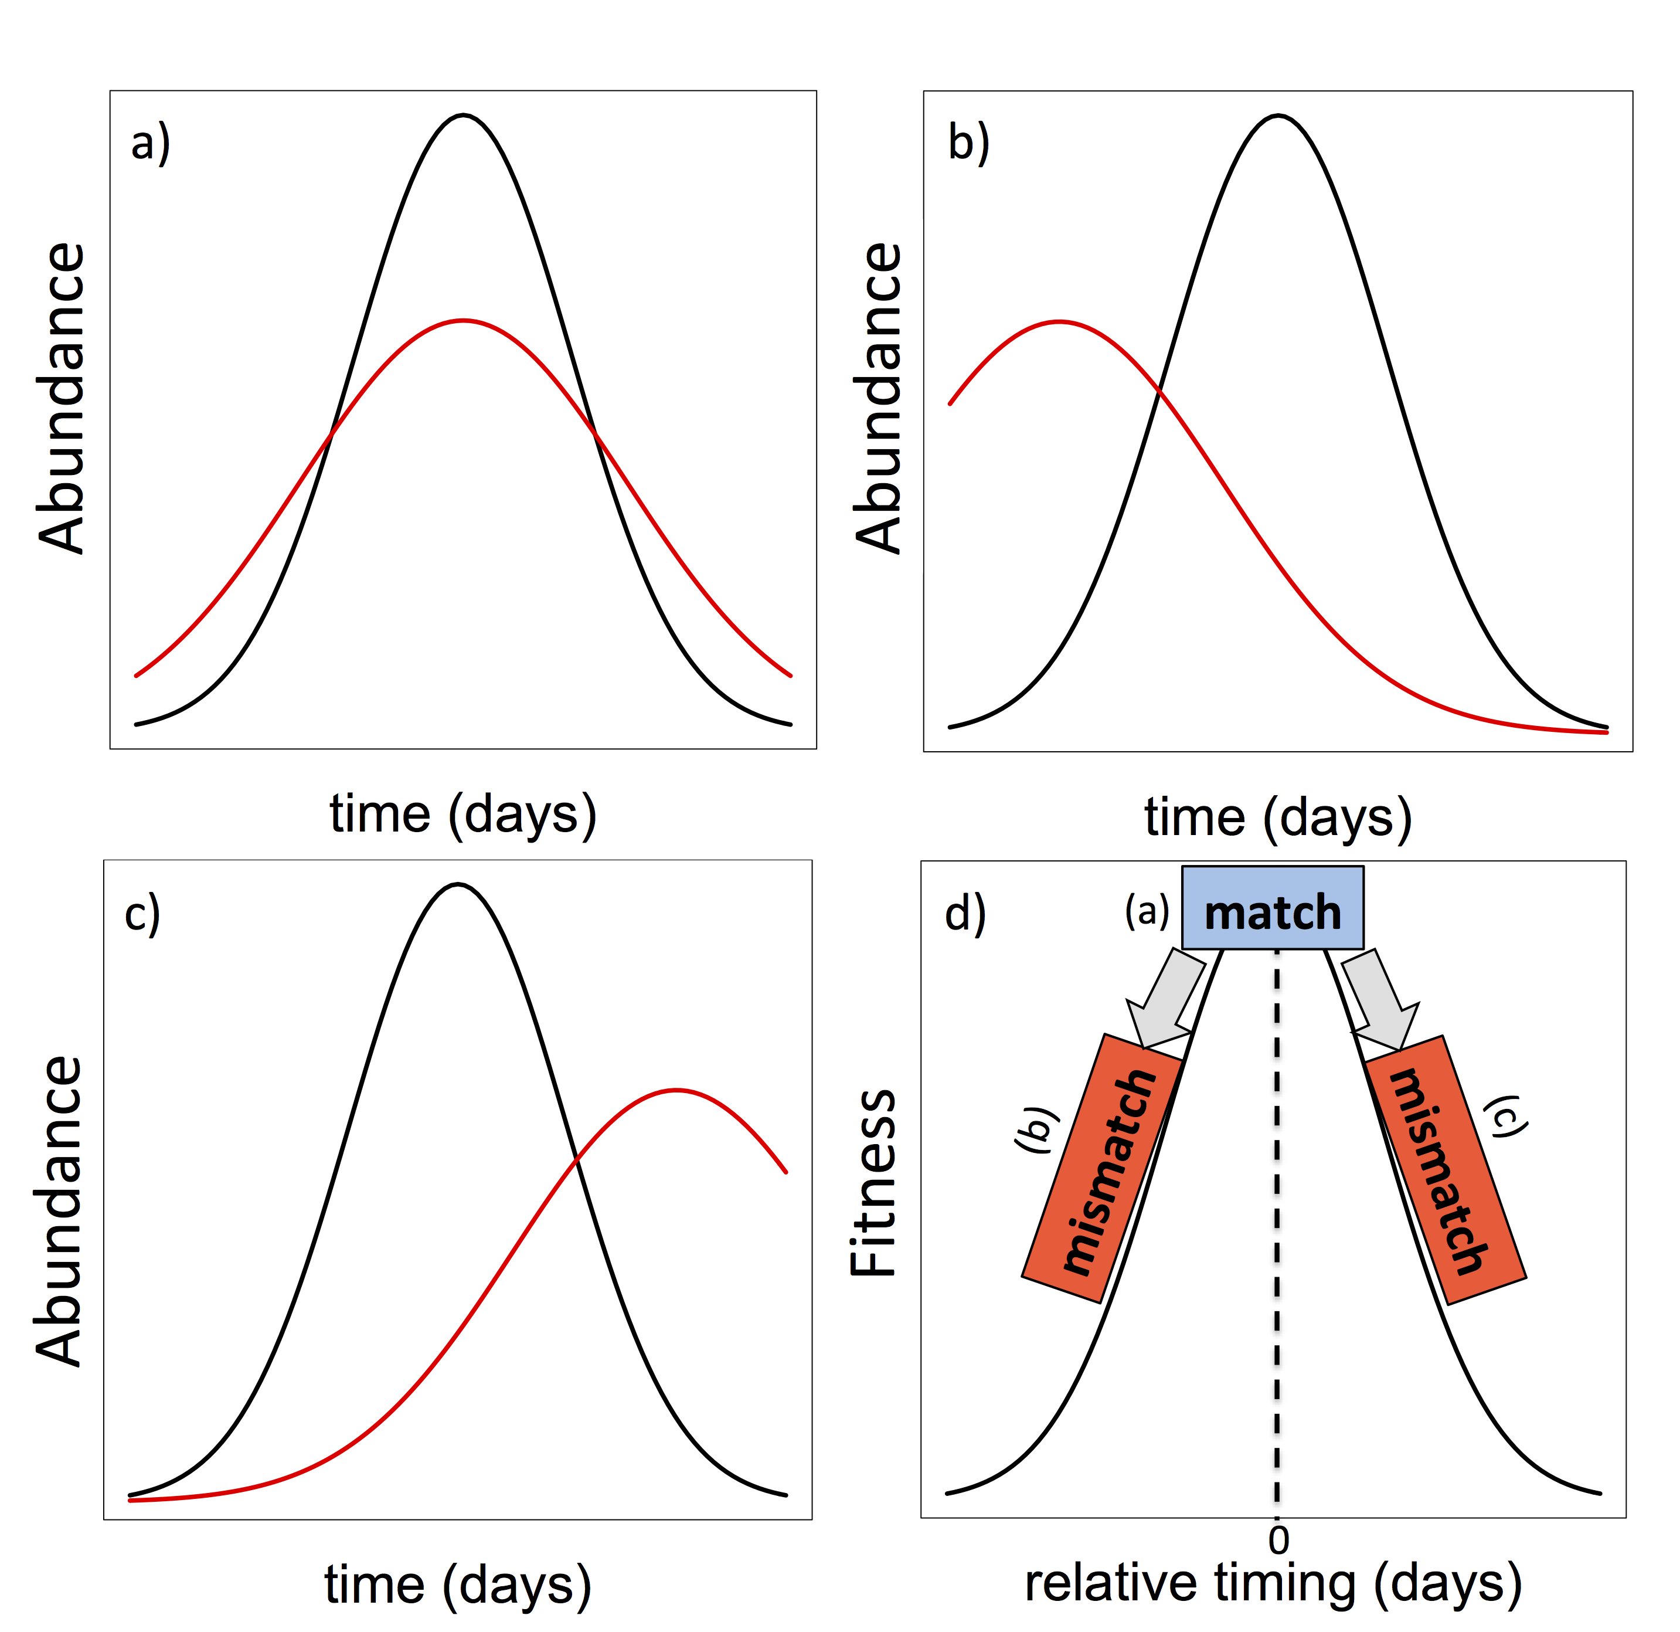

Figure 2.

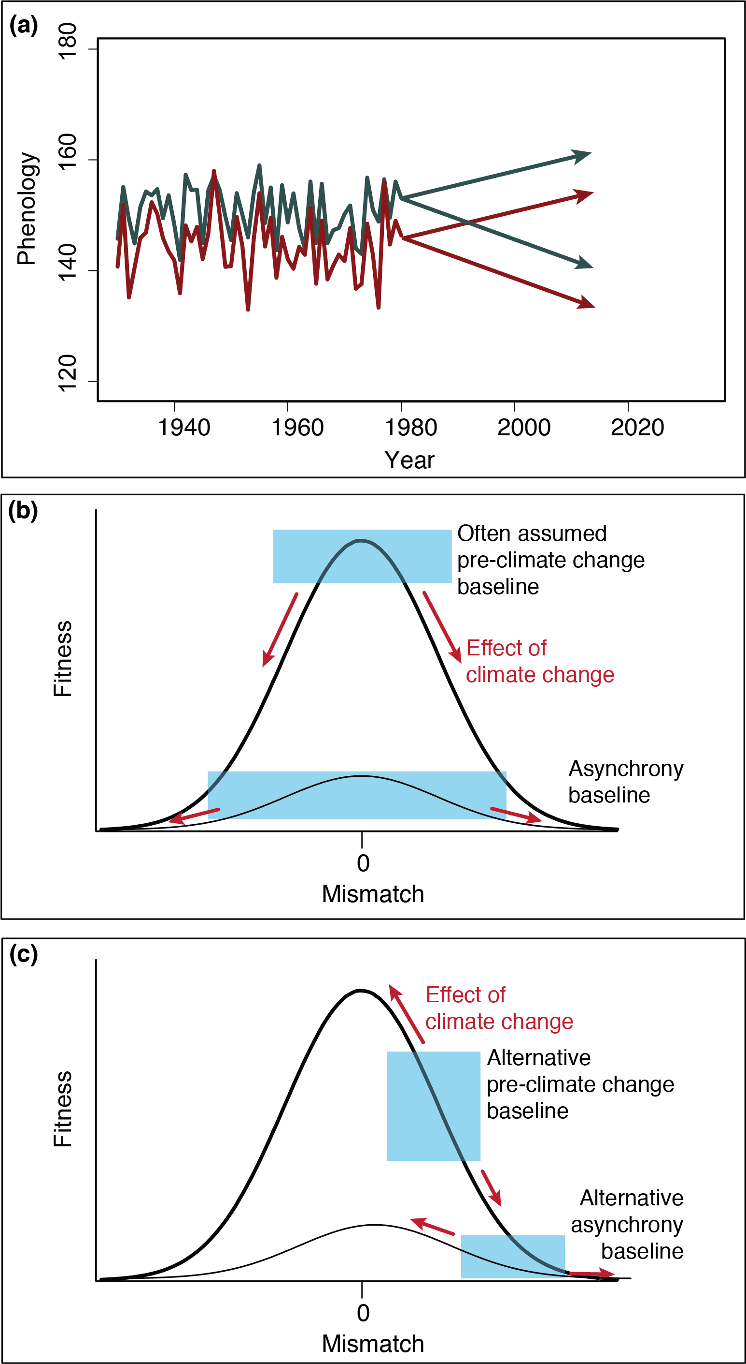

Figure 3.

